EXPERIMENT 12

12.1.1//Phone num e database management
Ans: ALGORITHM:
Step 1: Start
Step 2: Read integer n (number of commands)
Step 3: Create an empty dictionary ph
Step 4: Repeat steps for i = 1 to n
- Read command input and split into list cmd
- If cmd[0] == "ADD"
  - Add contact → ph[name] = number
- Else if cmd[0] == "REMOVE"
  - Remove contact using pop()
- Else if cmd[0] == "DISPLAY"
  - If dictionary is empty → Print "No contacts"
  - Else → Sort dictionary keys and print name:number
Step 5: Stop

FLOWCHART:
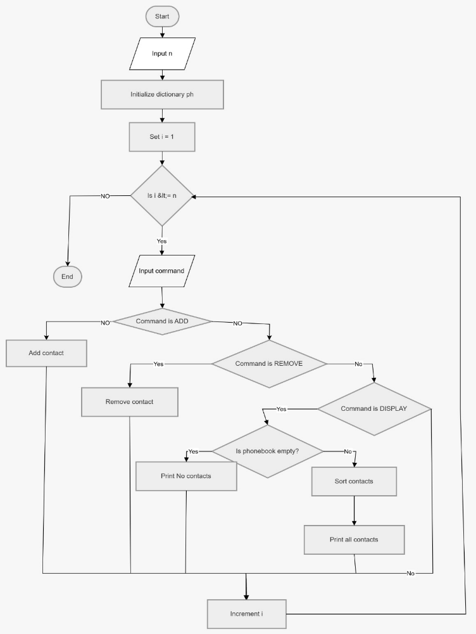

CODETANTRA:
